**Assignment 2**

1) Alter Table:

Add a new column linkedin_profile to employees table to store LinkedIn URLs as varchar.

Change the linkedin_profile column data type from VARCHAR to TEXT.

Add unique, not null constraint to linkedin_profile

Drop column linkedin_profile

--To add new column linkedin_profile as VARCHAR

ALTER TABLE employees

ADD COLUMN linkedin_profile VARCHAR(200);

Select * From employees;

-- To change linkedin_profile column data type from VARCHAR to TEXT

ALTER TABLE employees

ALTER COLUMN linkedin_profile TYPE TEXT;

Select * From employees;

--To update values without Null

UPDATE employees

SET linkedin_profile = 'linkedin' || employeeid

WHERE linkedin_profile IS NULL;

---To add Not null and Unique constraints

Alter Table Employees

ALTER COLUMN linkedin_profile SET NOT NULL,

ADD CONSTRAINT unique_linkedin UNIQUE(linkedin_profile)

-- To drop column linkedin_profile from employees table

ALTER TABLE employees

DROP COLUMN linkedin_profile;

-------------------------------------------------------------------------------------------------------------------------------------------------------------------------------------------------

2) Querying (Select)

Retrieve the employee name and title of all employees

Find all unique unit prices of products

List all customers sorted by company name in ascending order

Display product name and unit price, but rename the unit_price column as price_in_usd

- 1. Retrieve the employee name and title of all employees

SELECT

employeename,

title

FROM employees;

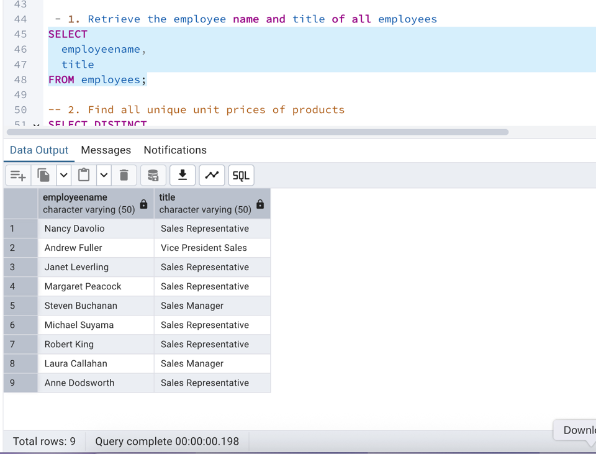

-- 2. Find all unique unit prices of products

SELECT DISTINCT

unitprice

FROM products;

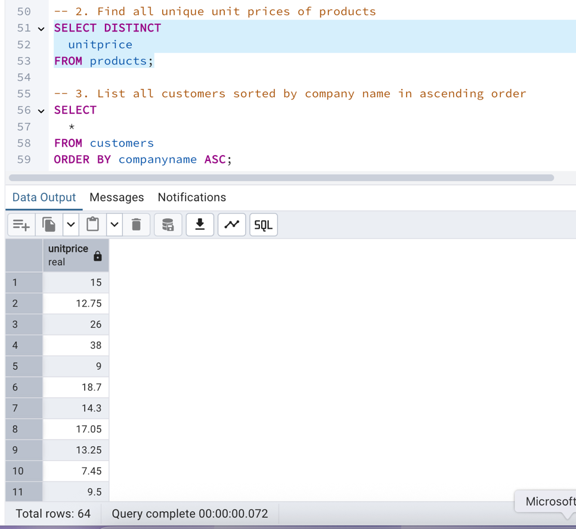

-- 3. List all customers sorted by company name in ascending order

SELECT

*

FROM customers

ORDER BY companyname ASC;

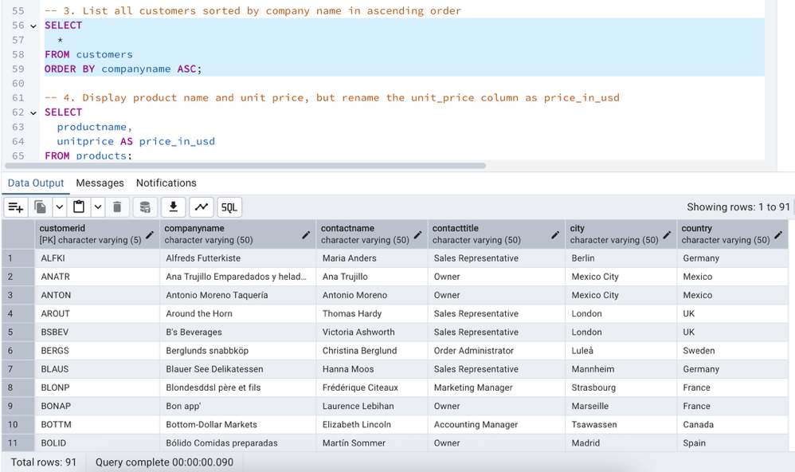

-- 4. Display product name and unit price, but rename the unit_price column as price_in_usd

SELECT

productname,

unitprice AS price_in_usd

FROM products;

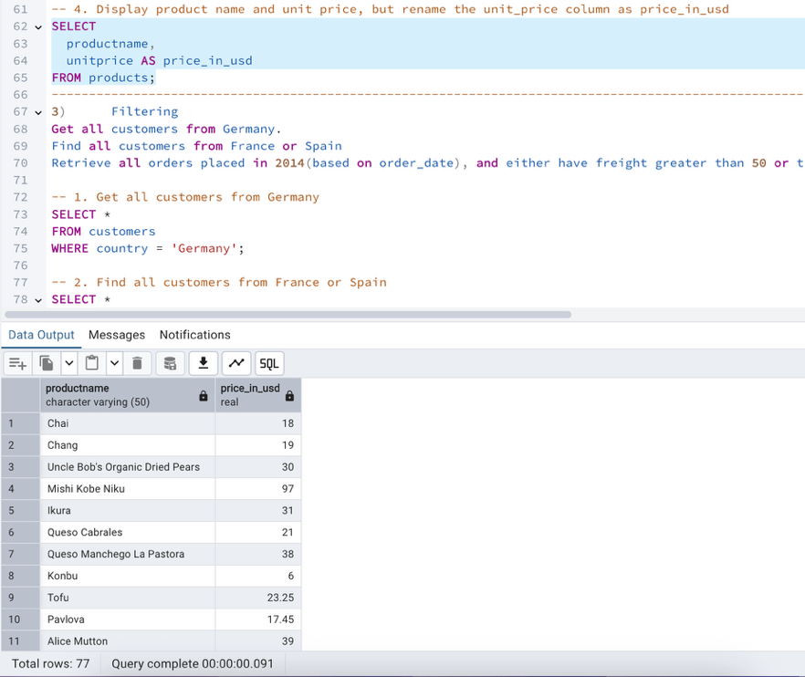

-------------------------------------------------------------------------------------------------------------------------------------------------------------------------------------------------

3) Filtering

Get all customers from Germany.

Find all customers from France or Spain

Retrieve all orders placed in 2014(based on order_date), and either have freight greater than 50 or the shipped date available (i.e., non-NULL) (Hint: EXTRACT(YEAR FROM order_date))

-- 1. Get all customers from Germany

SELECT *

FROM customers

WHERE country = 'Germany';

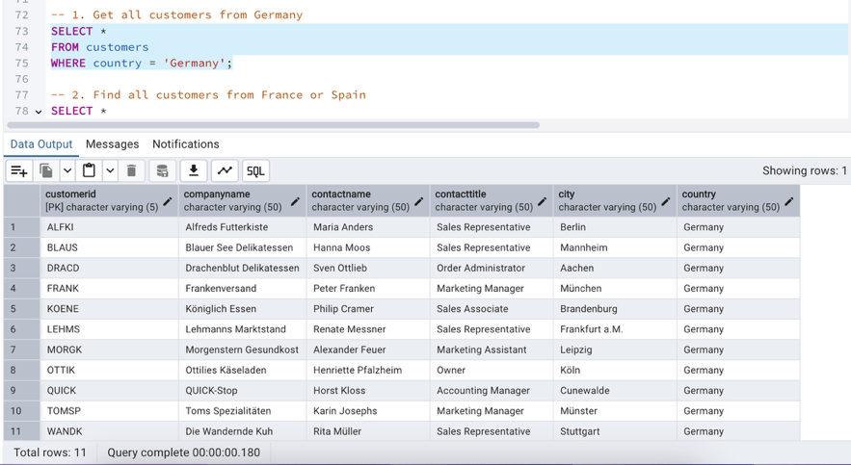

-- 2. Find all customers from France or Spain

SELECT *

FROM customers

WHERE country IN ('France', 'Spain');

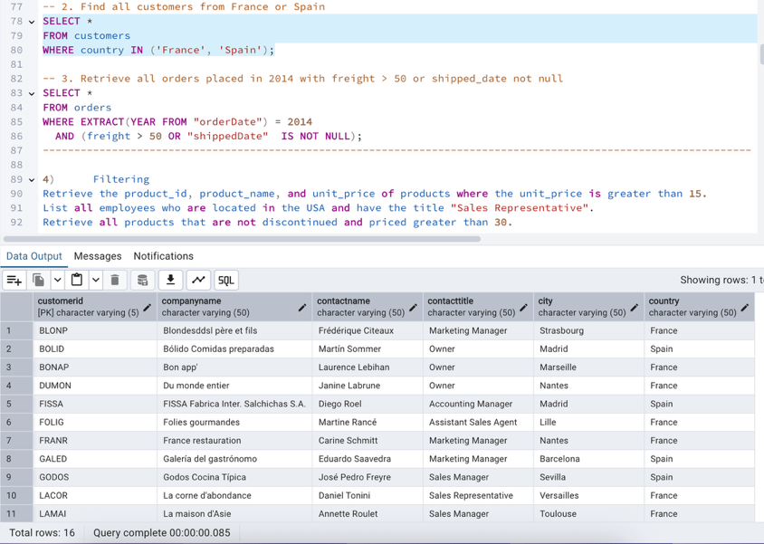

-- 3. Retrieve all orders placed in 2014 with freight > 50 or shipped_date not null

SELECT *

FROM orders

WHERE EXTRACT(YEAR FROM "orderDate") = 2014

AND (freight > 50 OR "shippedDate" IS NOT NULL);

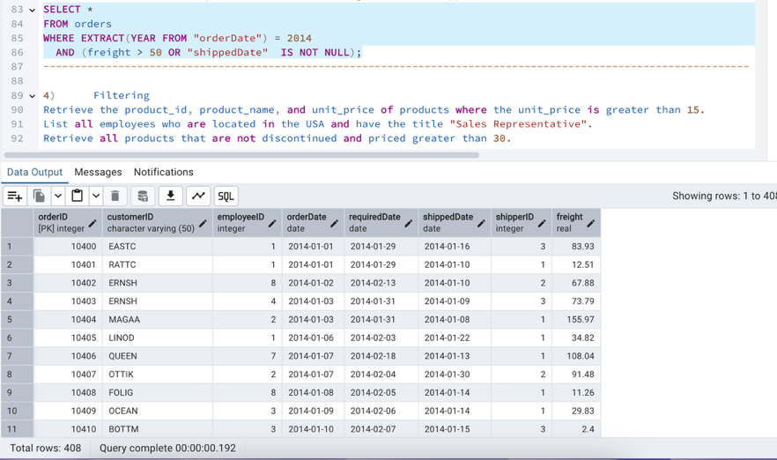

-------------------------------------------------------------------------------------------------------------------------------------------------------------------------------------------------

4) Filtering

Retrieve the product_id, product_name, and unit_price of products where the unit_price is greater than 15.

List all employees who are located in the USA and have the title "Sales Representative".

Retrieve all products that are not discontinued and priced greater than 30.

-- 1. Retrieve the product_id, product_name, and unit_price of products where the unit_price is greater than 15

SELECT

productid,

productname,

unitprice

FROM products

WHERE unitprice > 15;

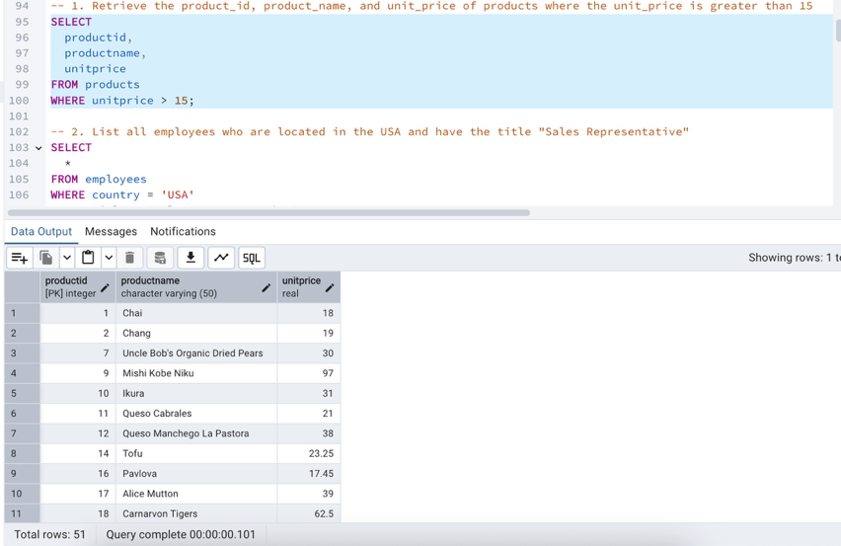

-- 2. List all employees who are located in the USA and have the title "Sales Representative"

SELECT

*

FROM employees

WHERE country = 'USA'

AND title = 'Sales Representative';

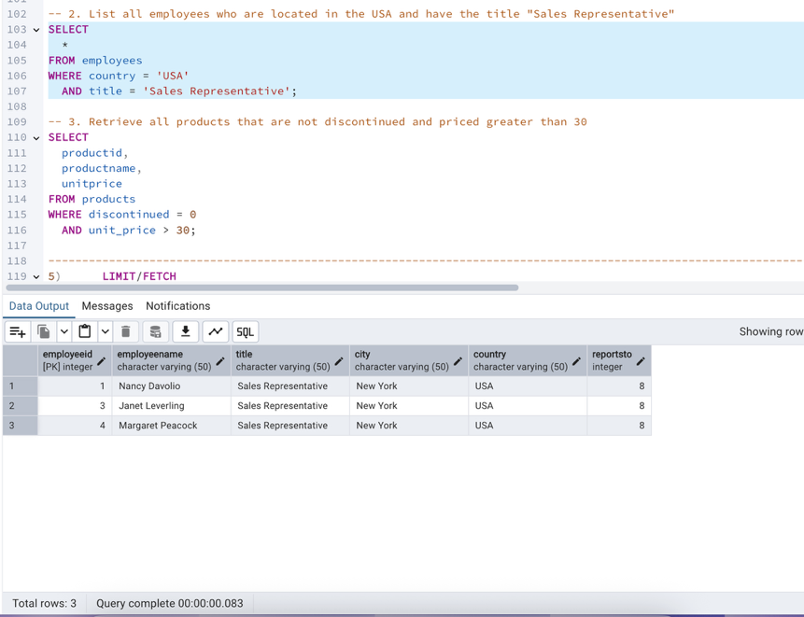

-- 3. Retrieve all products that are not discontinued and priced greater than 30

SELECT

productid,

productname,

unitprice

FROM products

WHERE discontinued = 0

AND unit_price > 30;

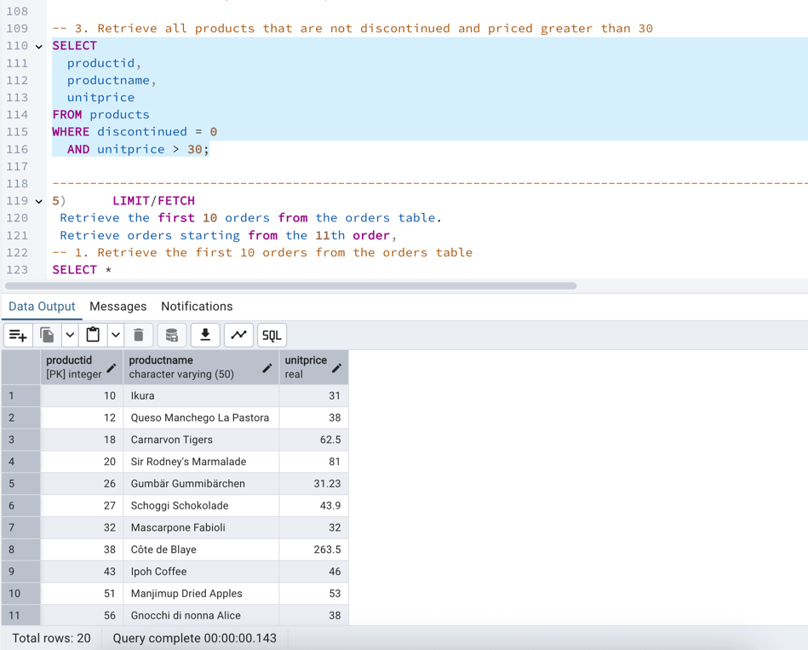

-------------------------------------------------------------------------------------------------------------------------------------------------------------------------------------------------

5) LIMIT/FETCH

Retrieve the first 10 orders from the orders table.

Retrieve orders starting from the 11th order,

-- 1. Retrieve the first 10 orders from the orders table

SELECT *

FROM orders

ORDER BY "orderID"

LIMIT 10;

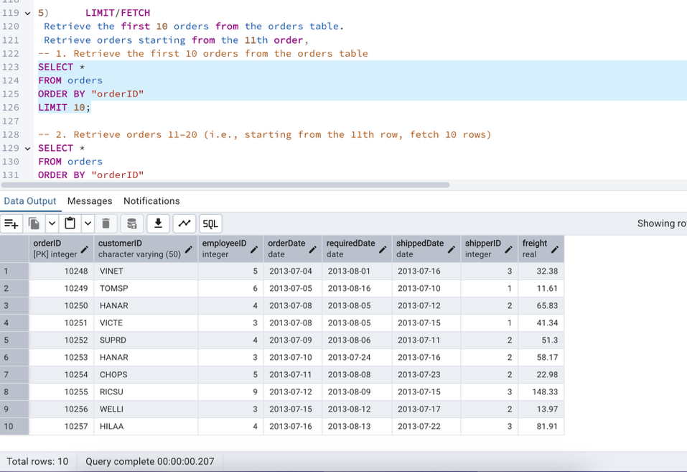

-- 2. Retrieve orders 11–20 (i.e., starting from the 11th row, fetch 10 rows)

SELECT *

FROM orders

ORDER BY "orderID"

OFFSET 10

LIMIT 10;

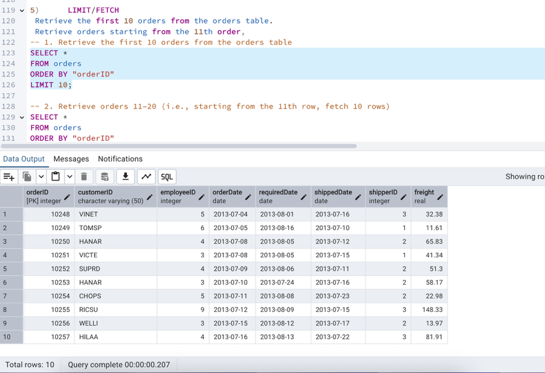

-------------------------------------------------------------------------------------------------------------------------------------------------------------------------------------------------

6) Filtering (IN, BETWEEN)

List all customers who are either Sales Representative, Owner

Retrieve orders placed between January 1, 2013, and December 31, 2013.

--1. List all customers whose contact title is either 'Sales Representative' or 'Owner'

SELECT *

FROM customers

WHERE contacttitle IN ('Sales Representative', 'Owner');

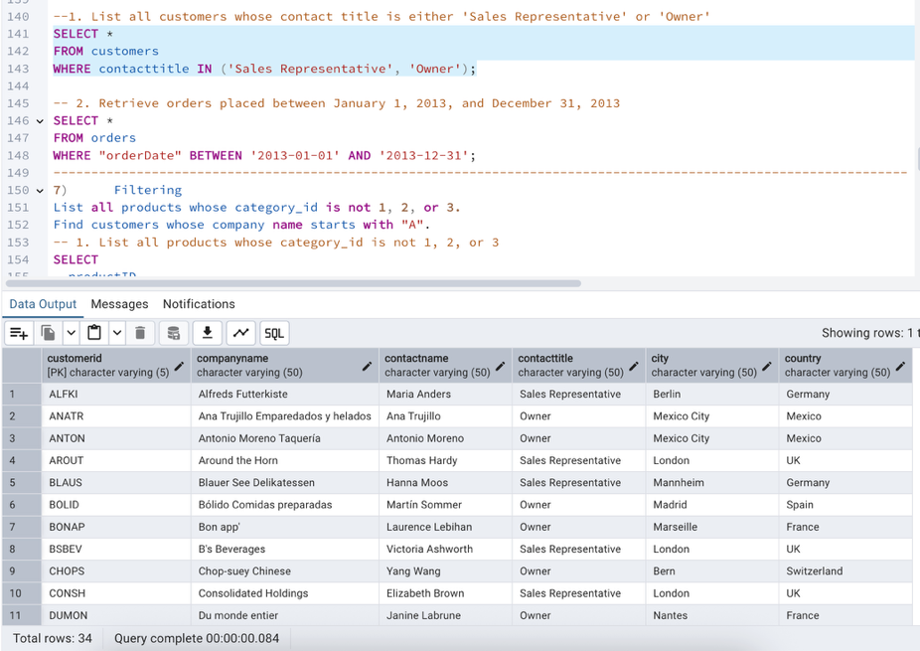

-- 2. Retrieve orders placed between January 1, 2013, and December 31, 2013

SELECT *

FROM orders

WHERE "orderDate" BETWEEN '2013-01-01' AND '2013-12-31';

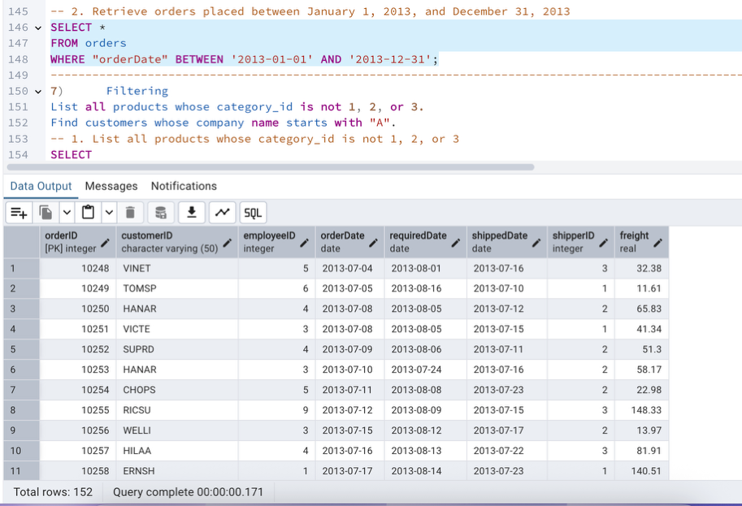

7) Filtering

List all products whose category_id is not 1, 2, or 3.

Find customers whose company name starts with "A".

-- 1. List all products whose category_id is not 1, 2, or 3

SELECT

productID,

productname,

categoryID

FROM products

WHERE categoryID NOT IN (1, 2, 3);

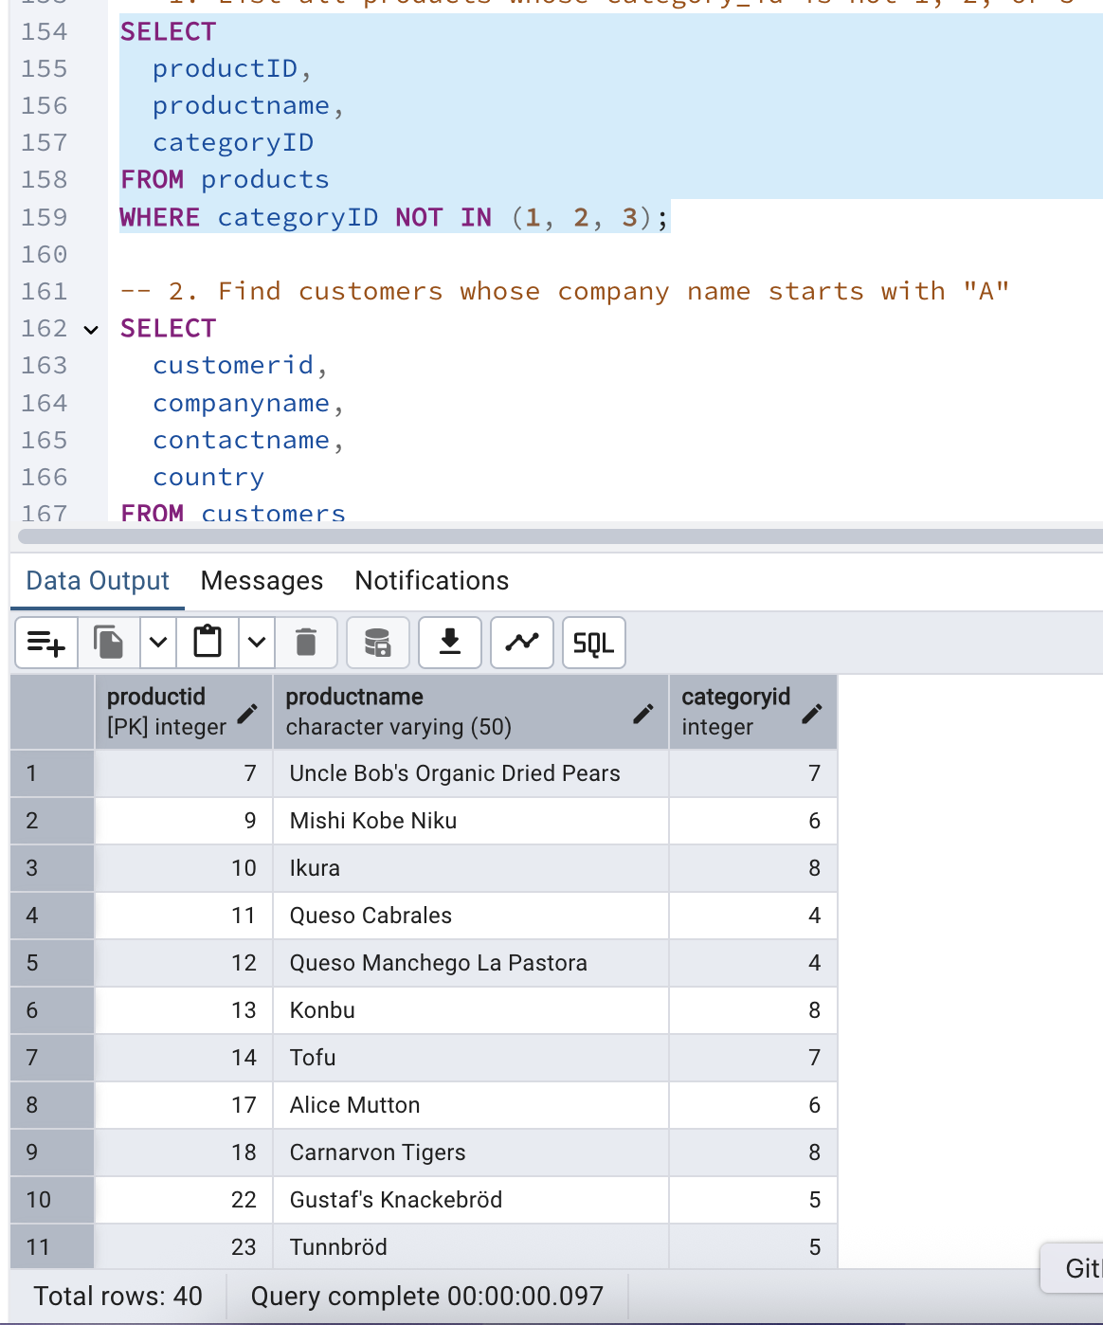

-- 2. Find customers whose company name starts with "A"

SELECT

customerid,

companyname,

contactname,

country

FROM customers

WHERE companyname LIKE 'A%';

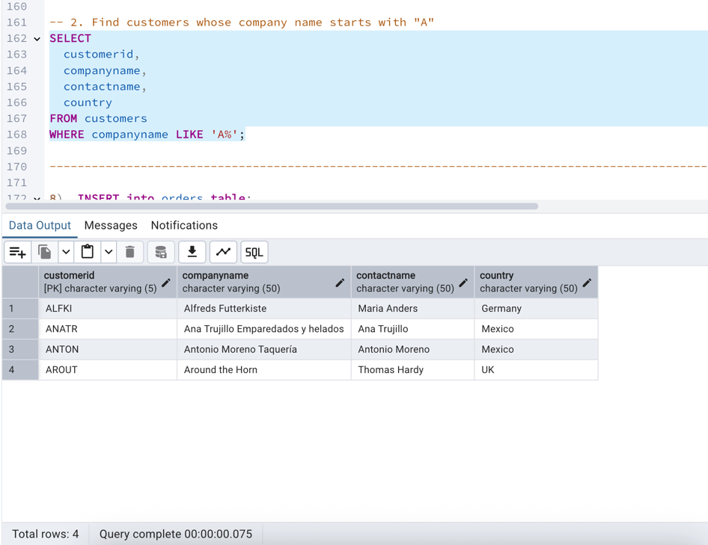

-------------------------------------------------------------------------------------------------------------------------------------------------------------------------------------------------

8) INSERT into orders table:

Task: Add a new order to the orders table with the following details:

Order ID: 11078

Customer ID: ALFKI

Employee ID: 5

Order Date: 2025-04-23

Required Date: 2025-04-30

Shipped Date: 2025-04-25

shipperID:2

Freight: 45.50

SELECT * from orders;

INSERT INTO orders (

"orderID",

"customerID",

"employeeID",

"orderDate",

"requiredDate",

"shippedDate",

"shipperID",

freight)

VALUES (

11078,

'ALFKI',

5,

'2025-04-23',

'2025-04-30',

'2025-04-25',

2,

45.50

);

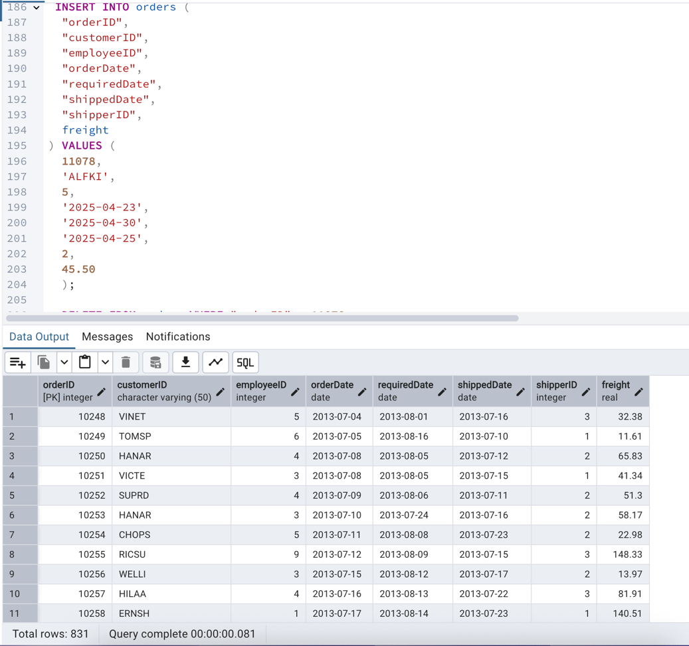

-------------------------------------------------------------------------------------------------------------------------------------------------------------------------------------------------

9) Increase(Update) the unit price of all products in category_id =2 by 10%.

(HINT: unit_price =unit_price * 1.10)

UPDATE products

SET unitprice = unitprice * 1.10

WHERE categoryid = 2;

SELECT * FROM products;

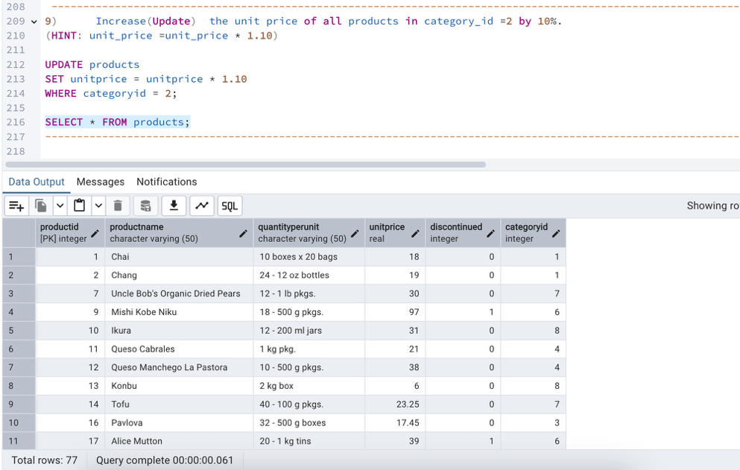

10) Sample Northwind database:

Download

 Download northwind.sql from below link into your local. Sign in to Git first <https://github.com/pthom/northwind_psql>

 Manually Create the database using pgAdmin:

 Right-click on "Databases" → Create → Database

Give name as ‘northwind’ (all small letters)

Click ‘Save’

Import database:

 Open pgAdmin and connect to your server

  Select the database  ‘northwind’

  Right Click-> Query tool.

  Click the folder icon to open your northwind.sql file

 Press F5 or click the Execute button.

  You will see total 14 tables loaded

  Databases → your database → Schemas → public → Tables

